

Group Members: | Tatheer Zahra (084)  Malaika Zahoor (072)  Tehreem Fayyaz (086)
Department: | BCS-III (B)
Course: | COAL (Project Document)
Instructor: | Sir Majid Shafique

Hex Editor Simulation (GUI Based)
Project Document
1. Project Title
Hex Editor Simulation (GUI Based) – COAL Project

2. Introduction
Hex Editor Simulation is a GUI-based project where the user can interact with memory addresses and hexadecimal values.
The project demonstrates COAL low-level memory concepts, including read/write operations, memory clearing, and file saving.

3. Tools & Technologies
Tool / Technology | Purpose
Visual Studio 2019/2022 | C++ GUI development
Win32 API | GUI components (buttons, textboxes)
C++ | Programming language
std::ofstream | Save memory state to file

4. Features
- GUI memory display (16 bytes: 0x00 – 0x0F)
- WRITE operation (store value at an address)
- READ operation (popup with memory value)
- CLEAR operation (reset memory)
- SAVE operation (store memory to memory_output.txt)
- Error handling (invalid address/value alerts)

5. Installation / Usage Instructions
- Open the project in Visual Studio 2019/2022
- Compile and run the project
- GUI window will open
- Usage steps:
  - Enter address (0–15) and hex value (00–FF)
  - Click WRITE → memory updated
  - Click READ → popup shows value
  - Click CLEAR → reset memory
  - Click SAVE → memory saved to file

6. Screenshots
(Insert GUI screenshot here)
- Address & Hex Value Input Boxes
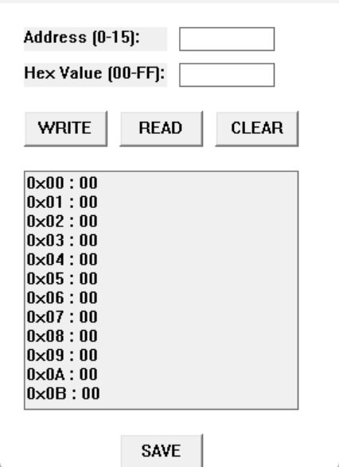
- WRITE, READ, CLEAR, SAVE Buttons
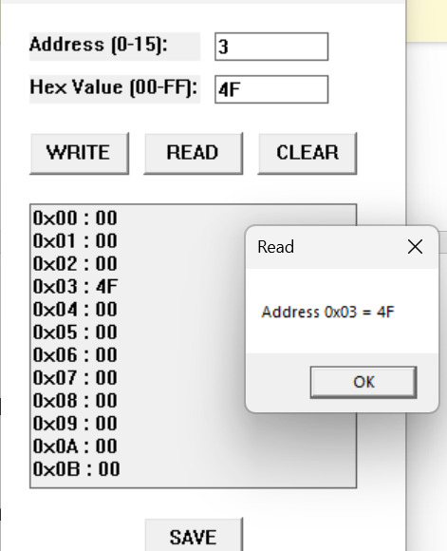
- Memory Display Box
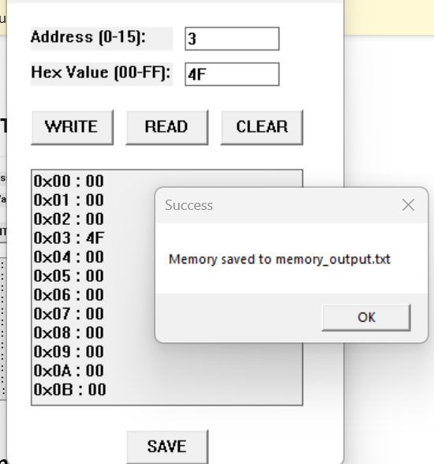

7. Flowcharts

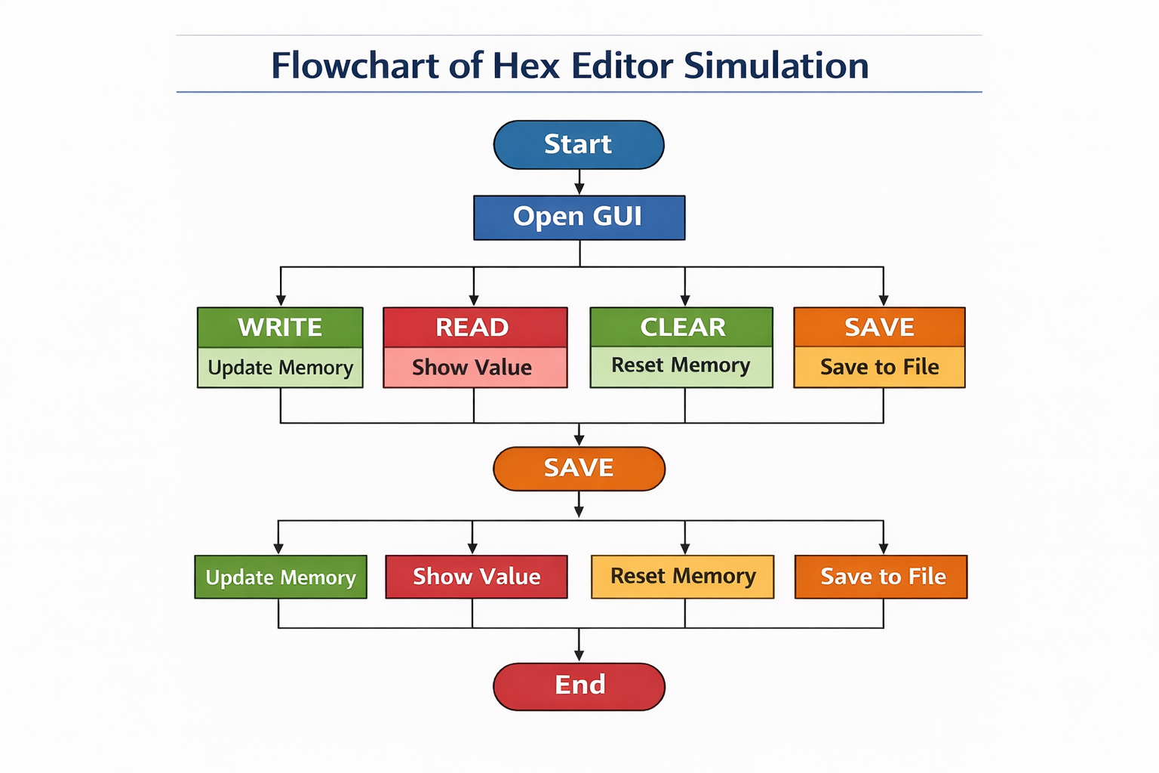

8. Working Steps
- Run the program
- Enter address and hex value
- WRITE → updates memory display
- READ → shows value in popup
- CLEAR → reset memory
- SAVE → stores memory in file

9. Code Snippet

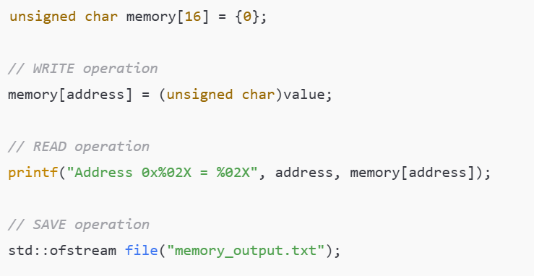

10. Advantages
- User-friendly GUI
- Error handling included
- Memory state persistent via file save
- Demonstrates COAL memory concepts practically

11. Group Task Distribution
Member Name | Responsibilities
Tatheer Zahra | Prepare project report (objective, conclusion, key concepts) and organize GUI screenshots
Tehreem Fayyaz | Develop GUI-based C++ code, implement WRITE/READ/CLEAR/SAVE, test memory and error handling
Malaika Zahoor | Prepare document (instructions, screenshots, memory output examples), integrate file save, format document

12. Conclusion
Hex Editor Simulation project provides a practical understanding of memory addressing and hexadecimal operations.
GUI interface with read/write/clear/save operations simulates a real-life hex editor, making COAL low-level concepts visually clear.

